osVAC Neo
Documentation
Version 0.5

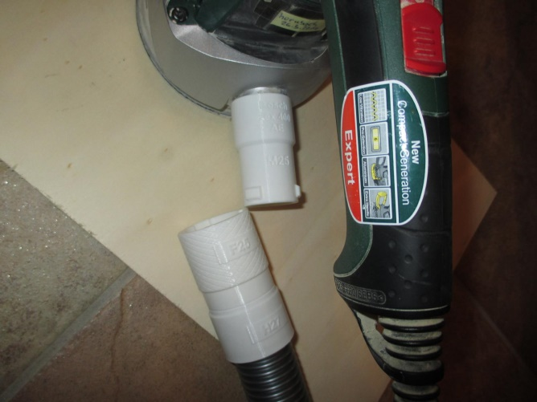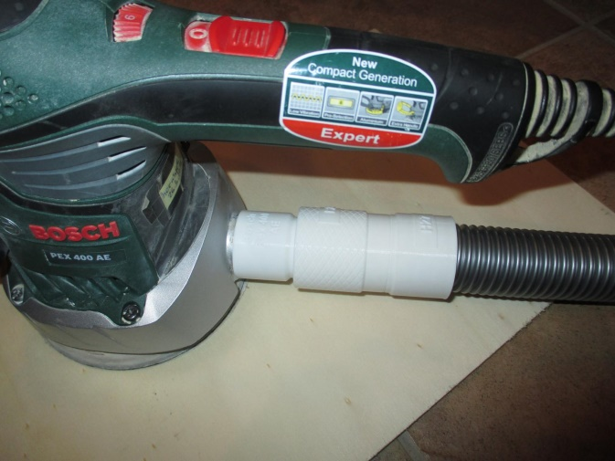

Version | Date | Comment
0.4 | 2022-06-16 | added information how to import osVAC Neo files  added information how to change diameters
0.5 | 2022-11-29 | added general information about adapters

What is osVAC / osVAC Neo ?
osVAC ist a universal connector system to connect for example electrical hand tools with a vacuum cleaner.
History
osVAC was created by three students at "Hobbyhimmel". For details see:
https://ossso.de/osvac
Differences between osVAC and osVAC Neo
- osVAC only offers 32mm diameter for male and female adapters.
- osVAC does not provide Fusion360-based CAD-files.
- osVAC doesn't provide a additional seal ring
Is osVAC Neo compatible with existing osVAC adapters?
yes :-)
Fusion 360 Installation
Install Fusion 360.
Install the addin:
https://apps.autodesk.com/FUSION/de/Detail/Index?id=2114937992453312456&appLang=en&os=Win64
Documentation:
https://parametrictext.readthedocs.io/en/stable/
The addin automatically updates the diameter printed onto the adapters.

Adapters and Connectors
A connector has two adapters and most of the time a transition cone. 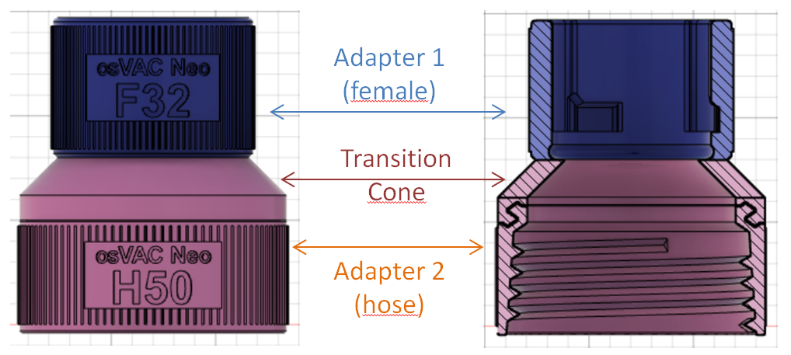
Male Adapter
There is a (so called) male adapter. Its name ist M plus a number. The number means the inner diameter of the adapter in mm.
So, this picture shows a male adapter with an inner diameter of 32mm, called M32.
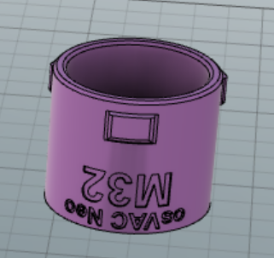
osVAC has only one diameter of 32mm. With osVAC neo you can create adapters of any diameter. Suggested diameters are 25, 32, 36, 40 and 50mm.

Female Adapter
The opposite of the male adapter is the female adapter. Its name ist F plus a number. So, this picture shows a female adapter F32, which can be combined with a M32.
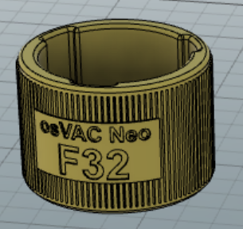
osVAC has only one diameter of 32mm. With osVAC neo you can create adapters of any diameter. Suggested diameters are 25, 32, 36, 40 and 50mm.

Hose Adapter
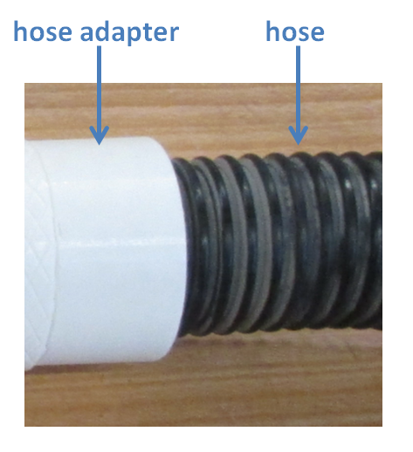
The hose adapter adapts to a hose. Its name ist H plus a number. The number means the inner diameter of the hose in mm.
So, this picture shows a hose adapter to a hose with an inner diameter of 36mm, called H36.
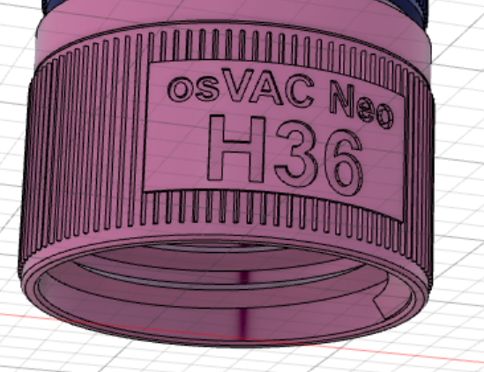
With osVAC neo you can create hose adapters of any diameter. Common hose diameters are 27, 32, 36, 40 and 50mm.

Cones and Cylinders as Adapters
Very often you need a cone or a cylinder as a adapter.
The next picture shows a cone with an inner diameter of 27.3mm and an outer diameter of 33.3mm at the end of the cone. At the beginning of the cone the inner diameter ist 31.3mm and the outer diameter is 37.3mm. The length of the cone is 48mm and the material width is 3mm. (This fits a Bosch PKS66 hand saw :-)
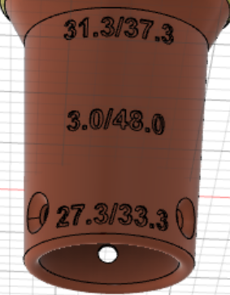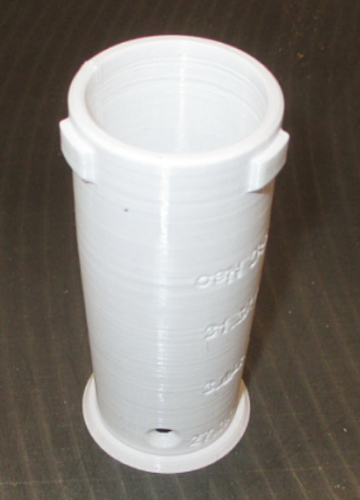
osVAC neo prints all numbers onto the adapter. The right picture shows the printed connector with a M32. Just by changing a few numbers you can create different cones:
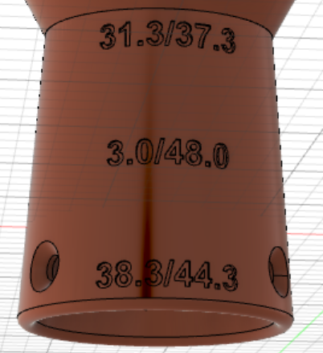

cylinders can be created, too:
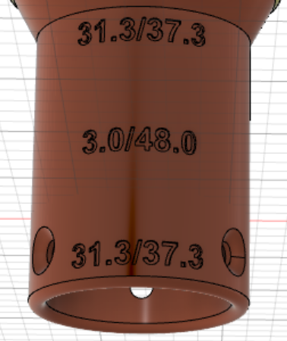

Import the osVAC Neo files to Fusion 360
Download the latest version of the file "osVACneo HoseAdapters vXXX.f3z" and "osVACneoDocumentation vXXX.docx" from https://magentacloud.de/s/pi6H3dBnxD4tfw3?path=%2F
Choose "Upload" and "Select Files"
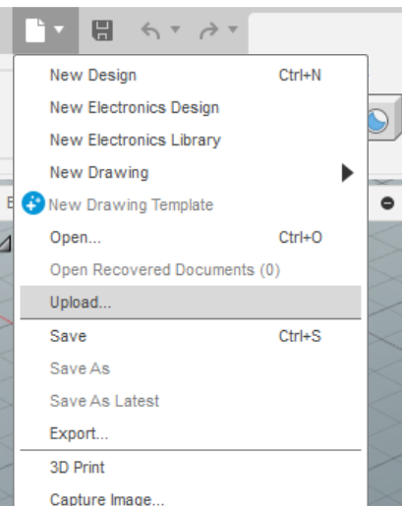 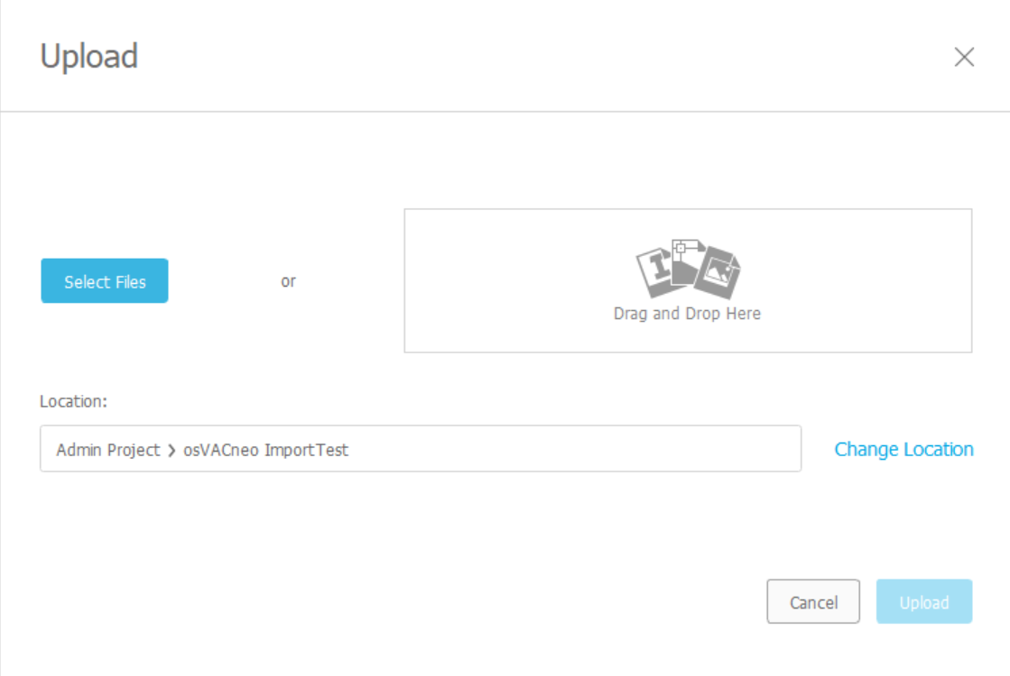
Choose "osVACneo HoseAdapters vXXX.f3z"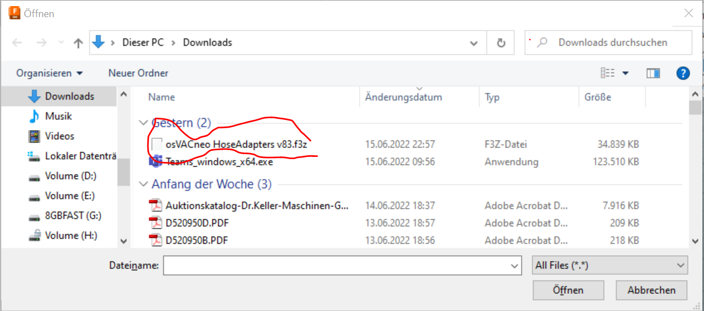
and choose "Upload"
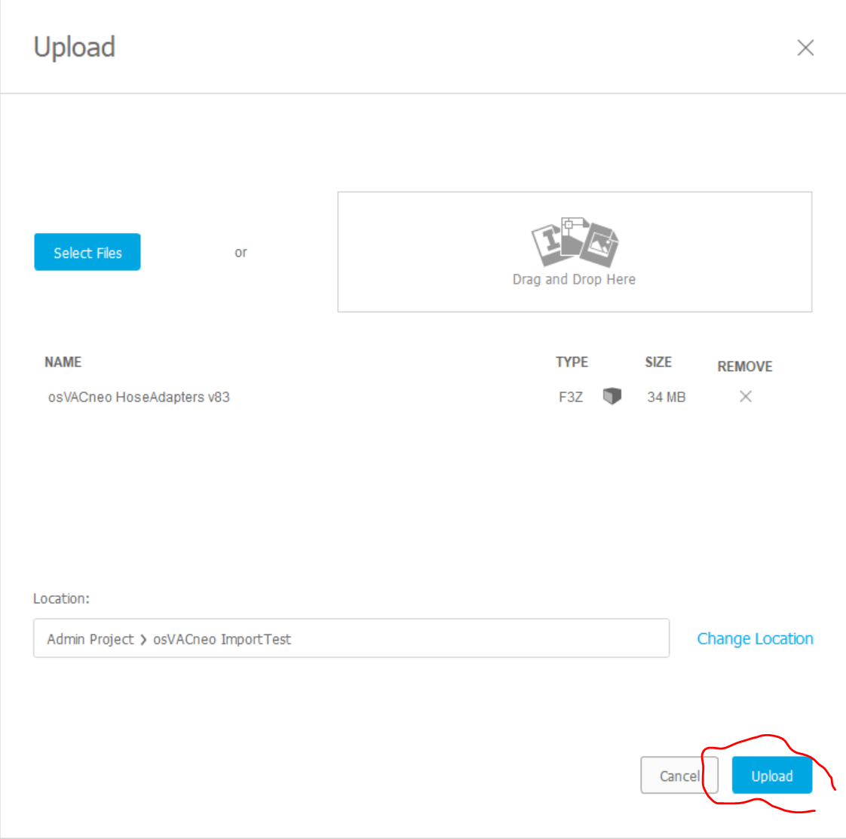

The upload may take several minutes.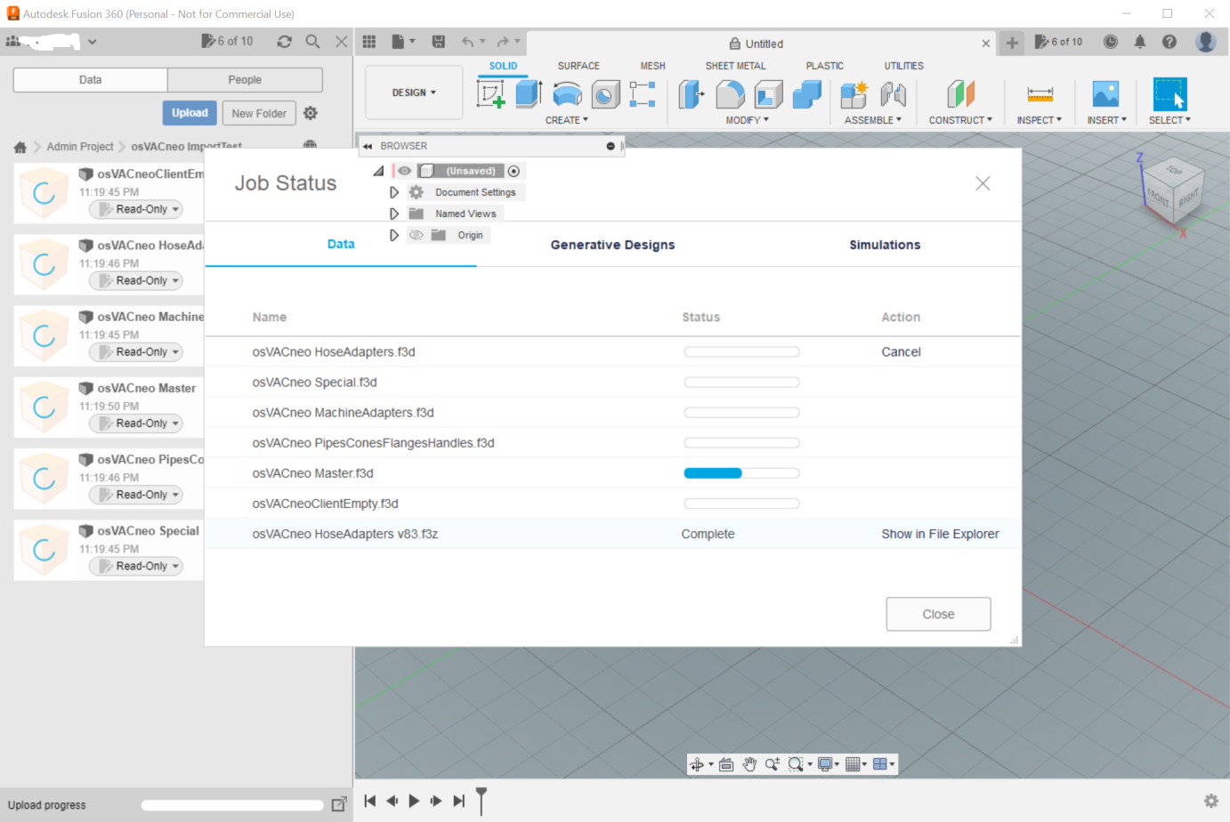
When the upload is done, it should look like this:
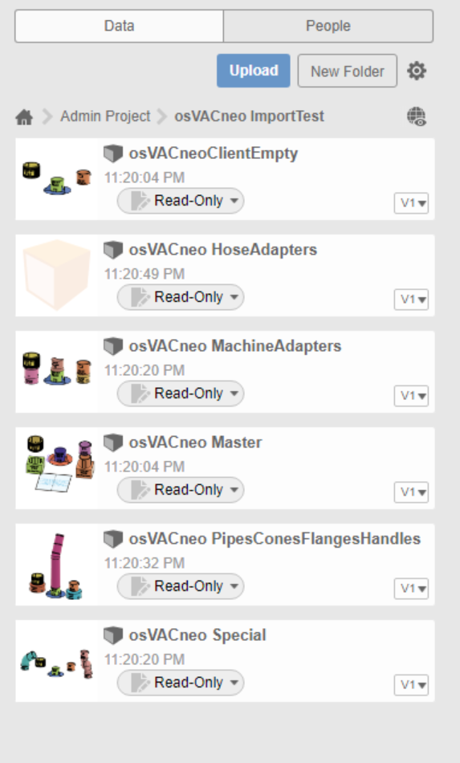

Basic settings
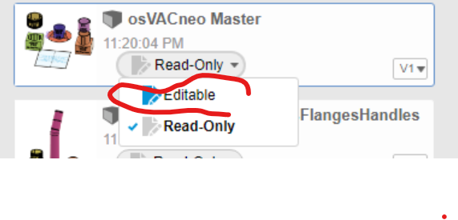
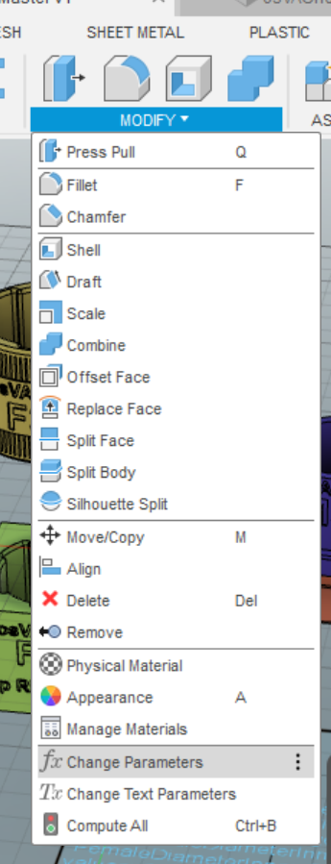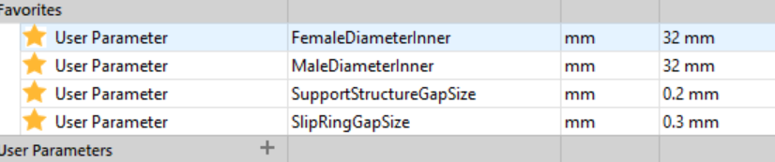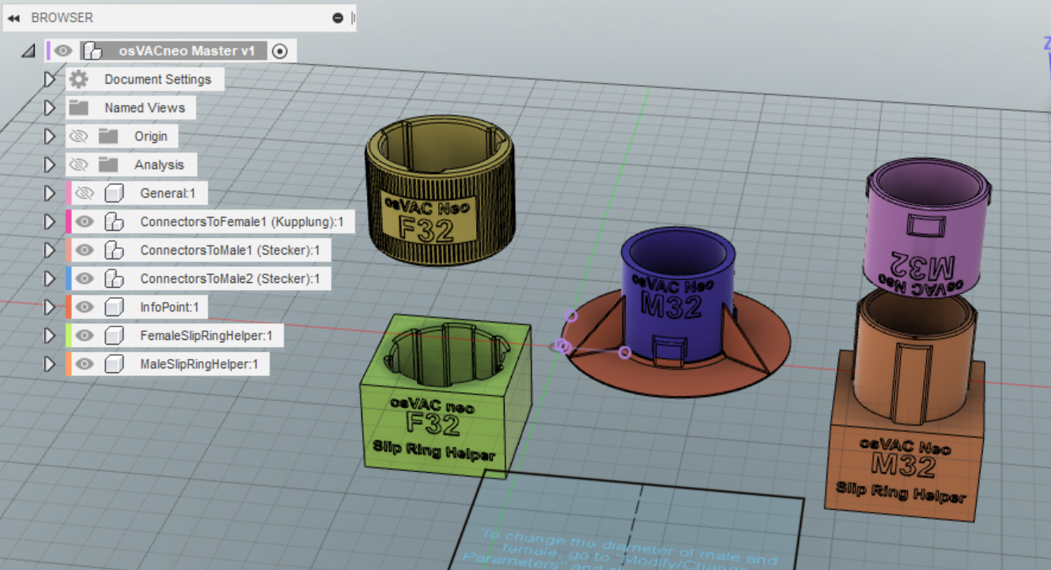
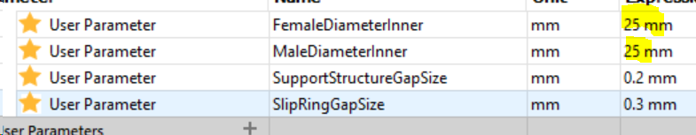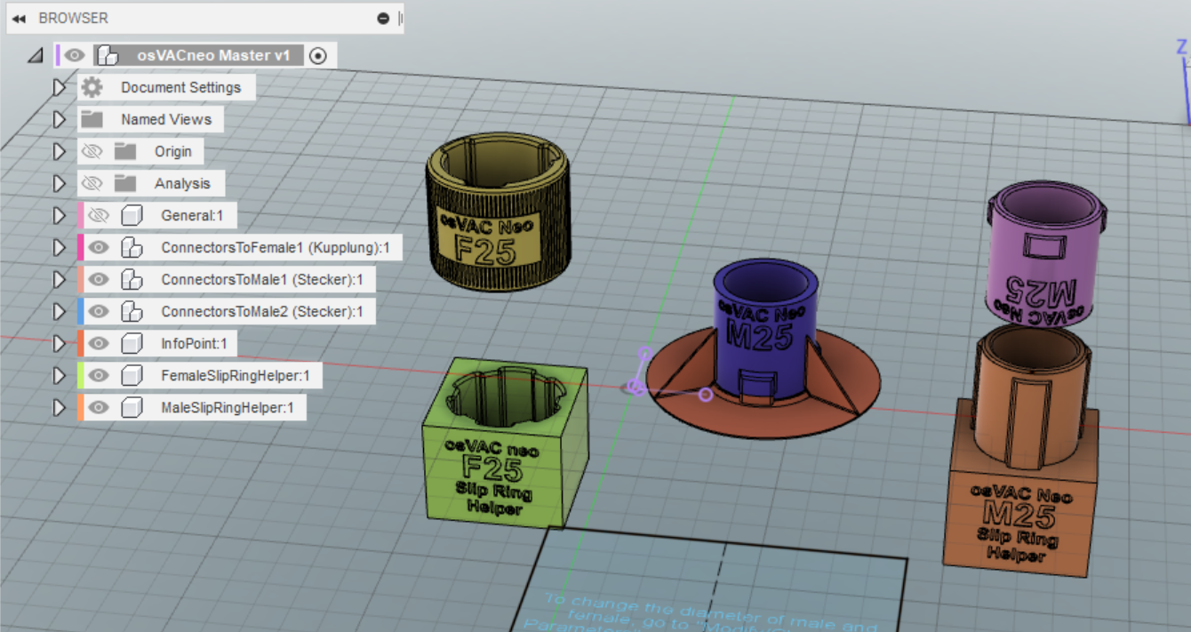
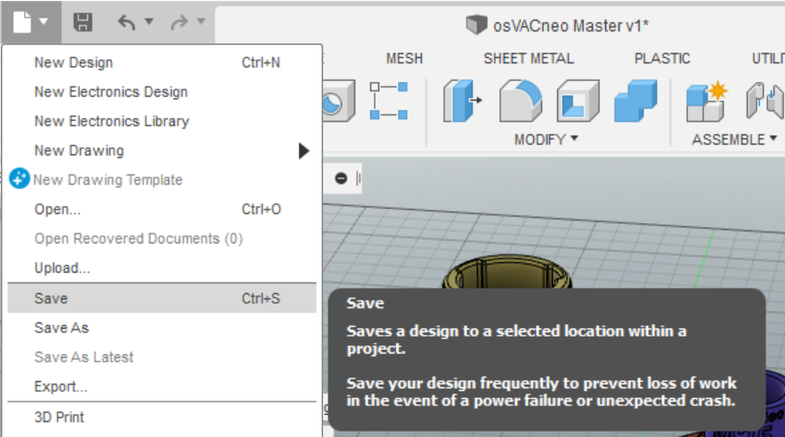

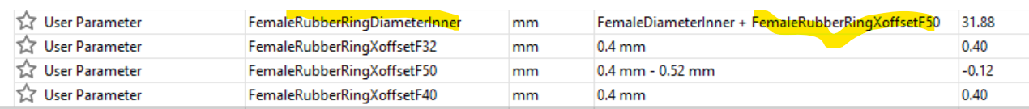
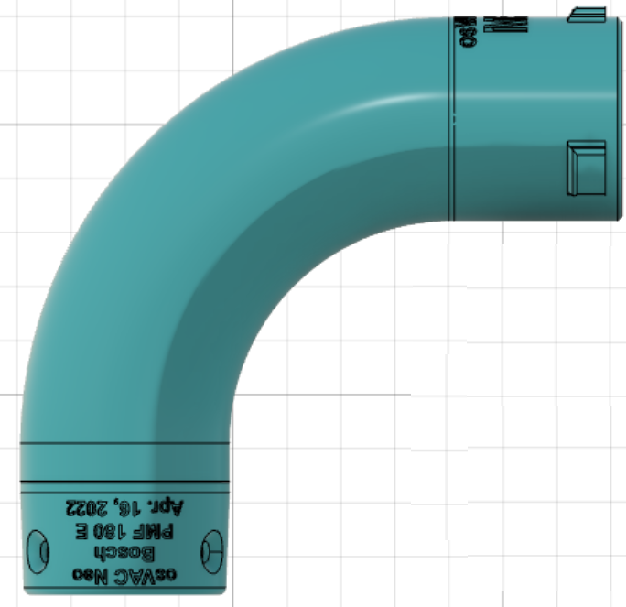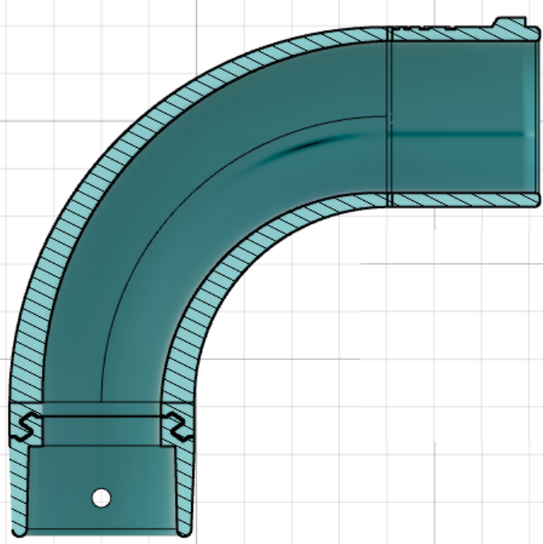

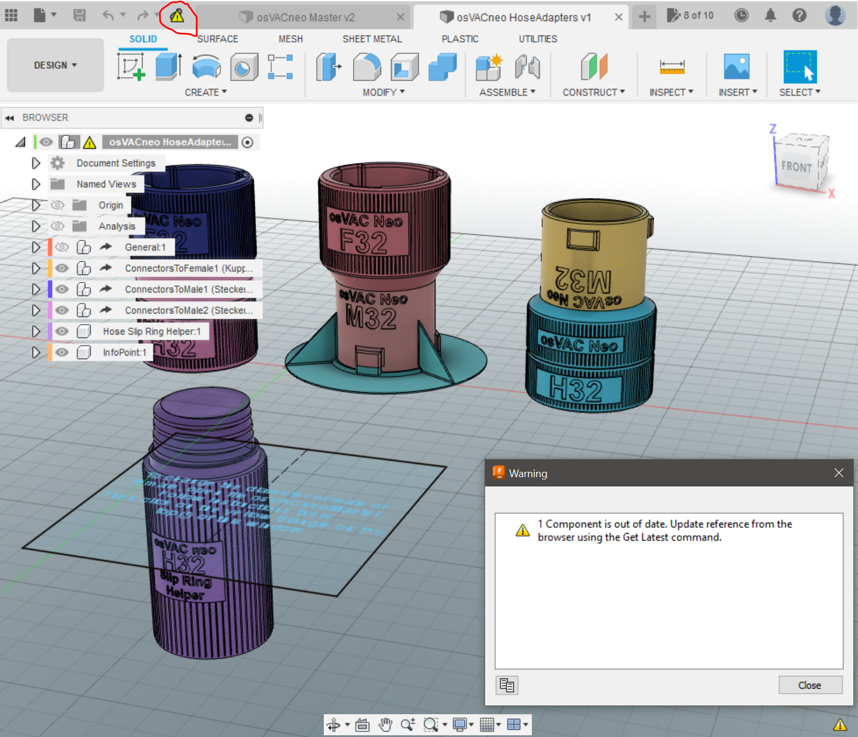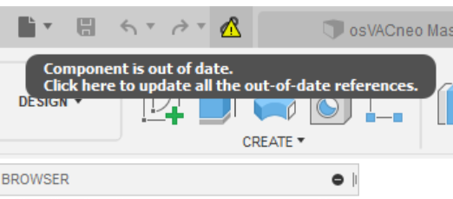
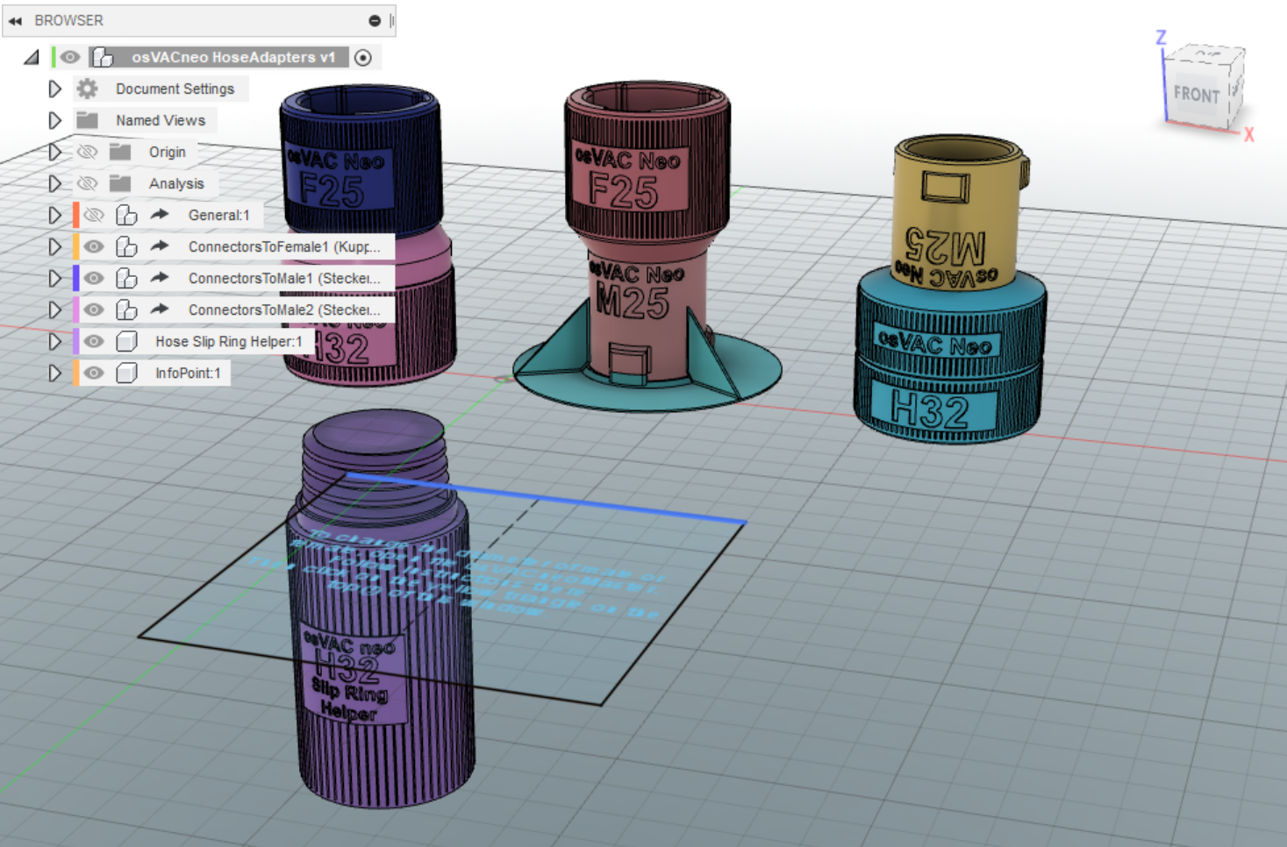
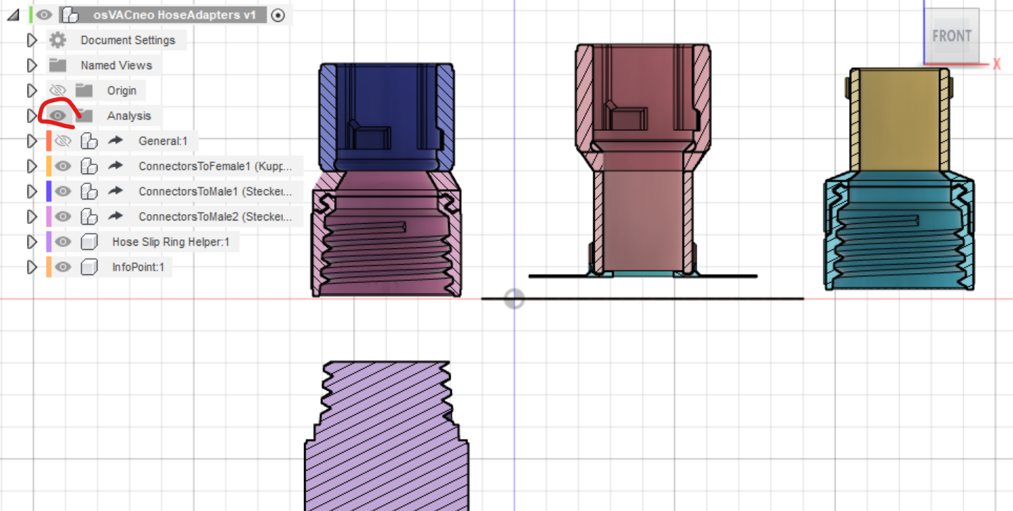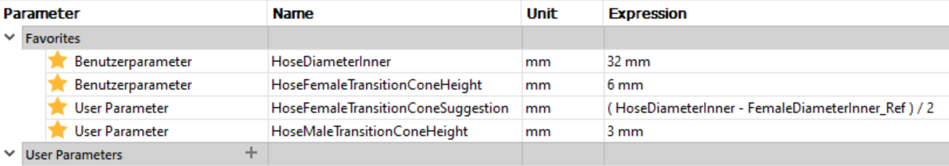

You can make one connector at a time.
First you need to decide, what the inner diameter of your male and female adapters should be. Hobbyhimmel only published 32mm. This is a good size for most vacuum cleaners. The most common hose is 32mm, too.
But for most electrical hand tools (sanders, etc.) adapters of 32mm are pretty big. Therefore I recommend to go to 25mm.
To choose these basic settings, open the file "Maste osVAC neoMasterr", go to Modify / Change Parameters and select FemaleDiameterInner. Set it to your value. Repeat for MaleDiameterInner.
If you want to use a hose adapter, also choose the inner diameter of your hose by setting HoseDiameterInner to your value.
If you change a parameter, F360 needs a few seconds to calculate the changes. All adapters will automatically be changed to the new diameters.
Click OK to close window.
Note: After closing the parameter window, it will take some time for graphics to update the printing on the adapters. Be patient.
Note: when the Plugin parametrictext isn't installed this will produce errors as without Fusion360 isn't able to use a parameter/variable inside a text box, which is used for putting up the description on the adapters.
Save the file.
Export STL-Data
After setting the basic parameters inside the master template you can then choose what to print. If you want to print the female adapter for the hose with the slip ring go to the design "osVACneoClientHoseAdapters". If you see a yellow sign telling you that the source model is outdated refresh it accordingly. (this imports the changes from the master template to the current design)
Check which part you need and then right click on the component you would like to print. Export the mesh:
Choose stl binary as format (3mf is more modern, but somehow has some artefacts in it ???).
Safe the stl file to your disk and open your Slicer.
Note: If you have a hiqh quality printer, the supportStructure isn't needed. Just hide the "SupportStructure" inside the collection and export the stl afterwards.

Slicer
you can either use Prusa Slicer or Cura. Depending on your 3d printer nozzle you might want to choose a different gap size for the slip ring in the female hose adapter
Half the size of your nozzle is a good starting point. (e.g. 0.4 nozzle --> set the gap to 0.2mm)

PrusaSlicer specific settings:
- use the 0,2mm quality profile with a 0,4mm nozzle
- with PLA use 3 top and 3 bottom layers for more stabilty
PLA and PETG are both working fine.

3D-Printing
Print it in the direction it exports. The hose part is on the plate and above is the female adapter.

Slip Ring
The osVAC Neo slip rings look like this (F32-H32 and M32-H32):
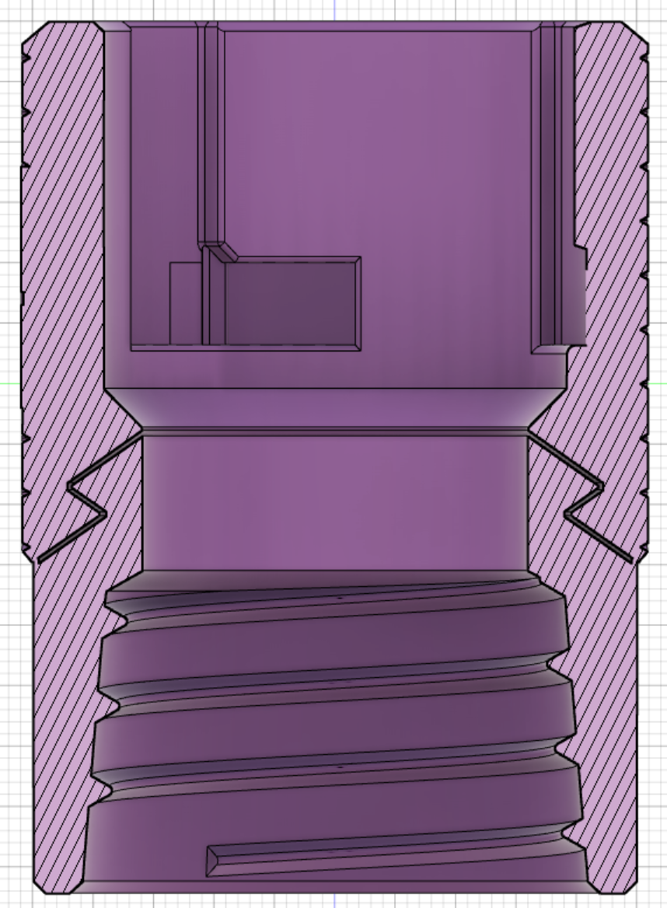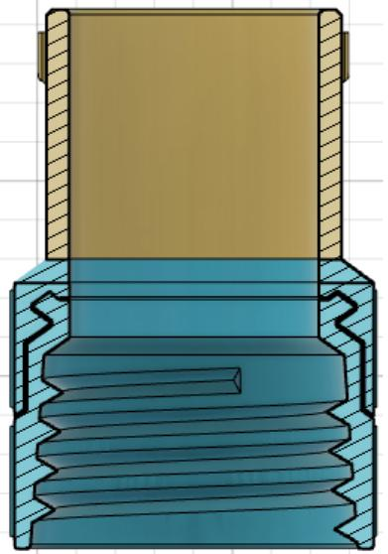
The original design from HobbyHimmel of the slip ring prints very well on my Ender 3 with a 0,4mm nozzle and a layer height of 0,2mm using PLA or PETG. Also my own version of the slip ring prints well with a the parameter SlipRingGapSize set to 0,2mm.
When I switched to a nozzle of 0,6mm and a layer height of 0,3mm 6 months ago, I increased the parameter SlipRingGapSize to 0,3mm and that works, too.
If you use my Fusion360-files, change the parameter SlipRingGapSize to your needs.
Usually I get the slip ring to work, just using my hands: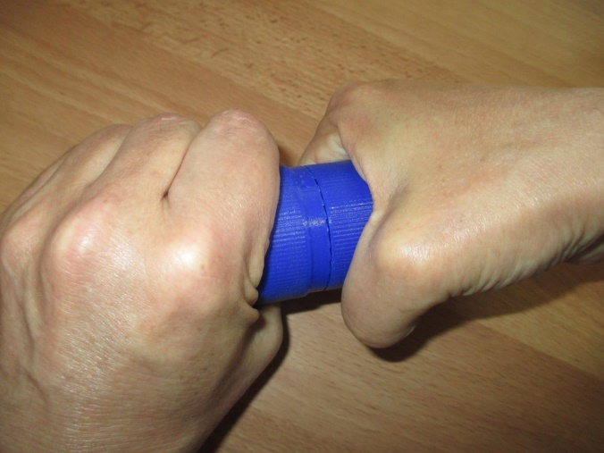
If that does not work, try to use a knife:
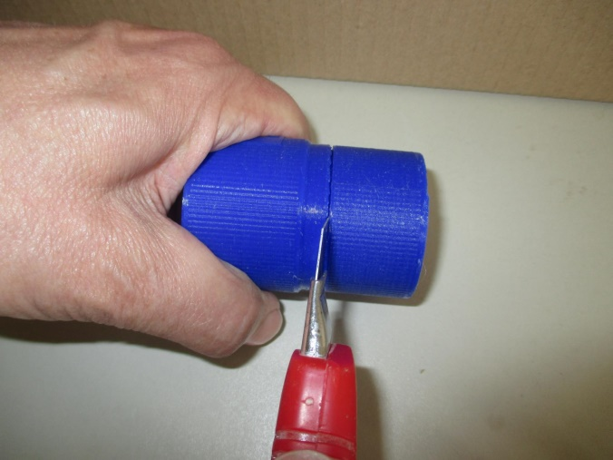
You may also try to use a very fine saw. But do not cut deep! Max 1mm!!
If that will not help, there are different ways to get the slip rings working.

using osVAC Neo Slip Ring Helper:
Here are some tools to get your slip rings to work:
So here, some tools, which I named "slip ring helper". If your slip ring will not rotate after printing. In the middle you see a F32-H32.
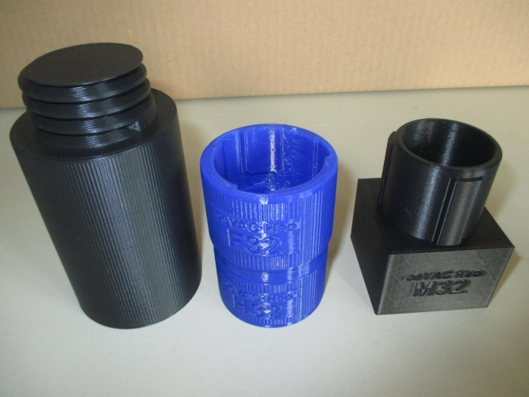
Place the right part in a vice.
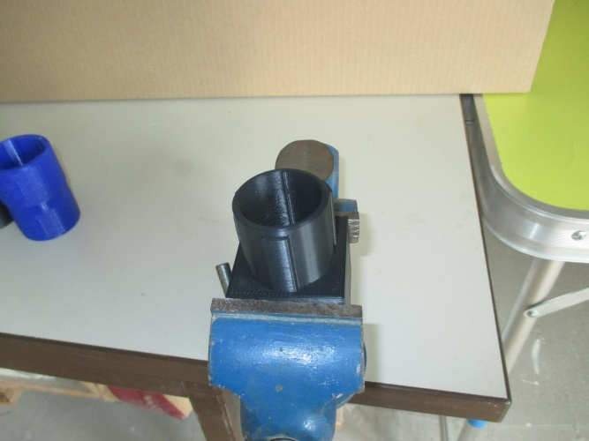
Put the F32H32 onto the part in the vice.
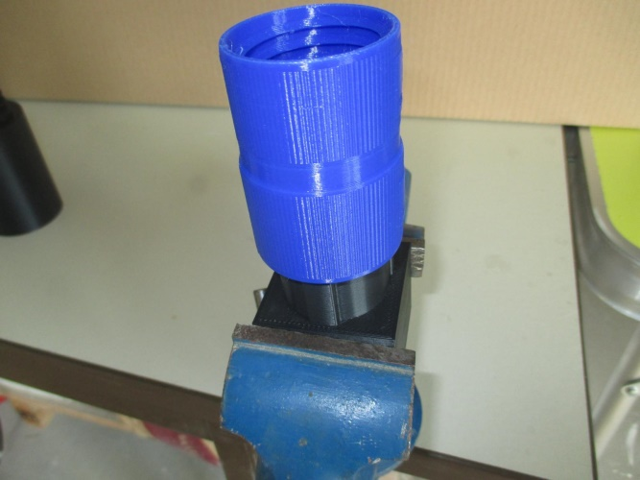 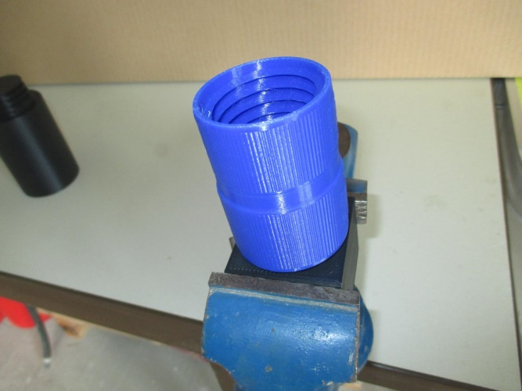
Then screw the other part into the H32 und do a quick left turn. The slip ring will break free.
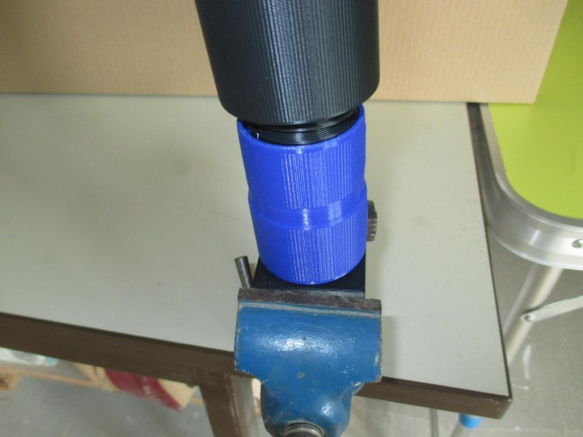 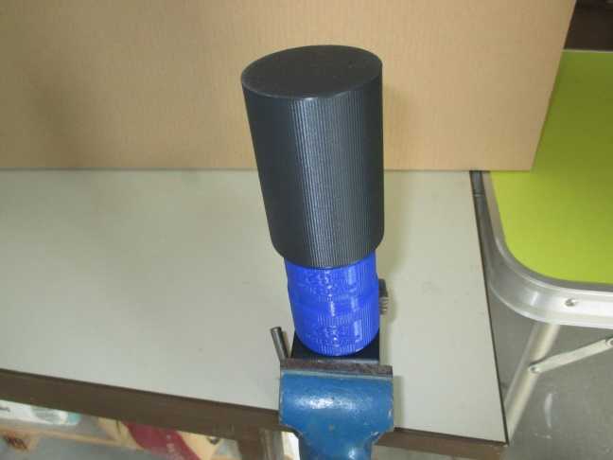
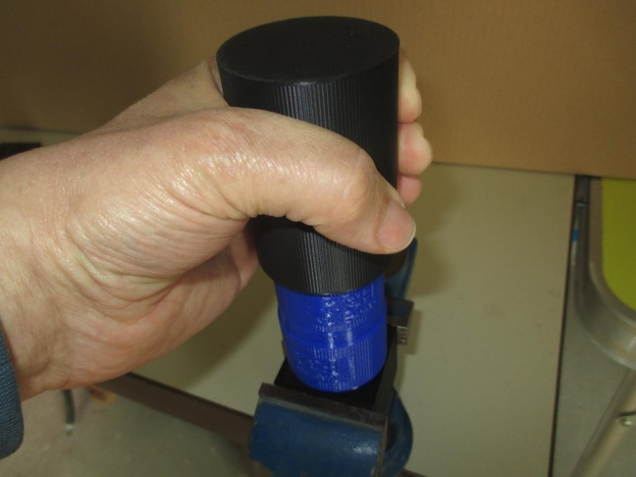

osVAC Neo has a M32-H32 with a slip ring, too. Here is the corresponding tool set: 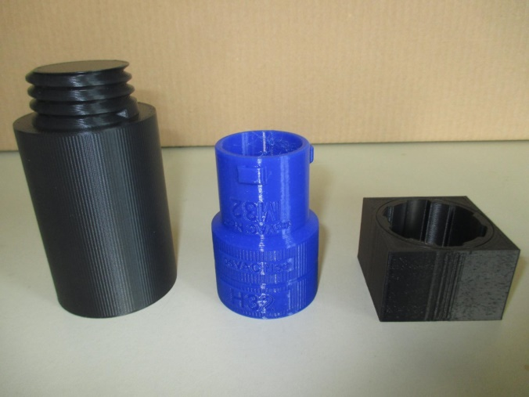 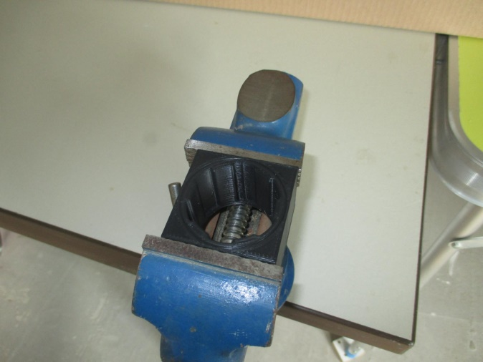
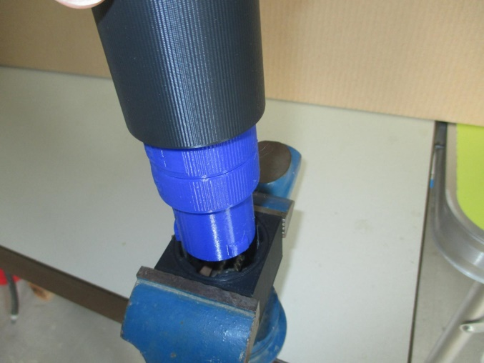

using other tools:
Before I designed the Slip Ring Helpers at first I used pliers: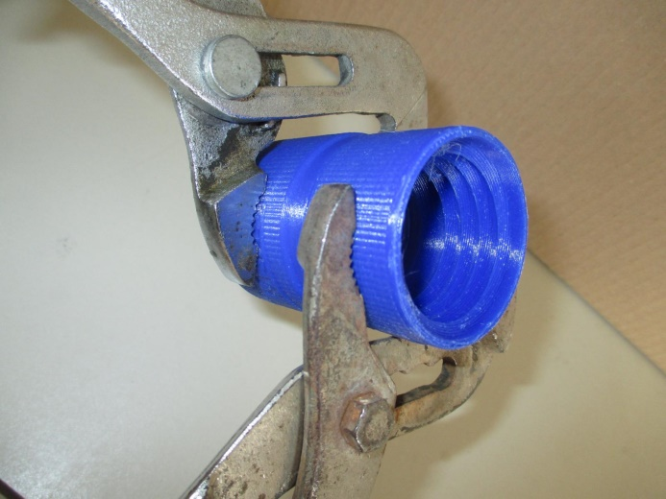
That works, if you are careful. Do not use to much pressure!
Then I got some "Bandschlüssel", which works better than pliers.
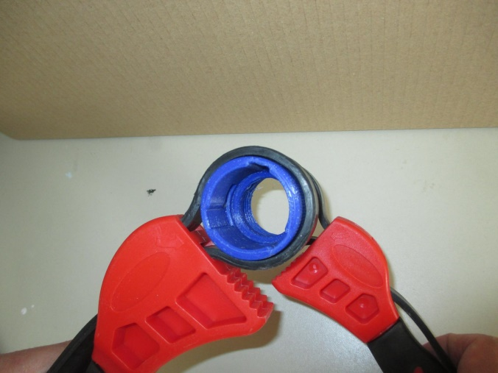 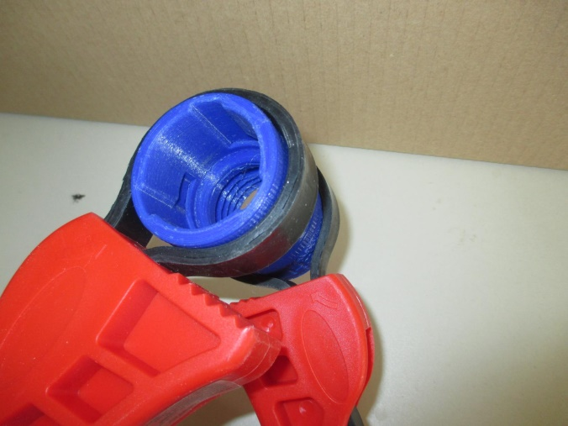
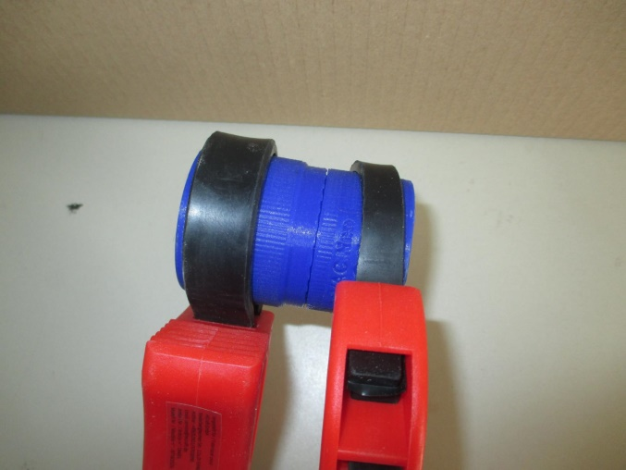

if this does not help:
If this does not help, probably something is wrong, how you pring osVAC Neo.
REVISIT for more Information.

How to add your own adapter

